DSA Project
Route Optimization
Group Members:
Abdul Moiz(01-134251-004)
Raja Arslan Haider(01-134251-074)
Contents
Problem Statement: 1
Objectives: 1
UML Class Diagram: 2
Source code: 2
Data Files: 2
Sample Program Output: 2
Performance Analysis: 3
Comparison Table: 3
Task Division: 3
Conclusion: 3
Citation: 3

Problem Statement:

The Travelling Salesman Problem (TSP) is a well-known problem in Data Structures and Algorithms where a salesman has to visit all cities exactly once and return to the starting city while covering the shortest possible distance. The main objective of this project is to implement and compare different algorithms used to solve the TSP.

The project uses both static and dynamic graph representations through adjacency matrices and linked lists. Algorithms such as Brute Force, Greedy (Nearest Neighbor), and a custom algorithm are implemented to compare their execution time, memory usage, and overall efficiency on graphs of different sizes. The project also includes graph visualization and performance analysis to study the behavior of each approach.

Objectives:
The objective of this project is to design and implement a system that solves the Travelling Salesman Problem (TSP) using different algorithmic approaches and graph representations. The system should:
- Accept city and distance input through files
- Represent the problem as a graph using adjacency matrix and linked list
- Compute the optimal or near optimal route between cities
- Implement Brute Force, Greedy, and Second Shortest Path Strategy algorithms
- Analyze execution time and memory usage
- Compare static and dynamic graph representations
- Visualize graph routes and connections using Qt GUI
The custom Second Shortest Path Strategy algorithm is a modified heuristic approach that may select the second shortest available path instead of always choosing the immediate shortest path. Considering first path might not be available. This helps generate alternative routes and demonstrates a different strategy for solving the TSP efficiently.

UML Class Diagram:
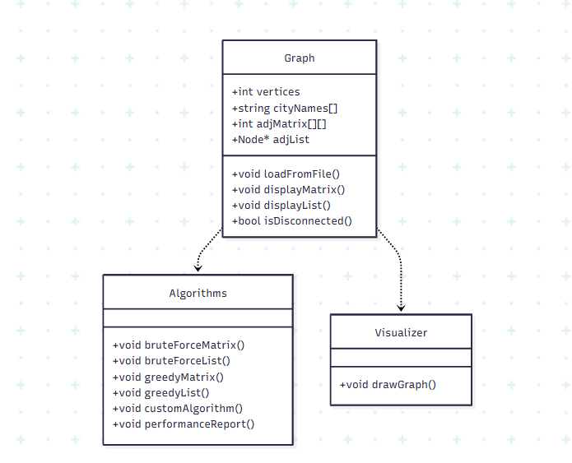

Source code:
https://github.com/abdulmoiz6062006/DSA-TSP-Project
https://github.com/RJ-ARSLAN/Travelling_Salesman_Problem

Data Files:

Sample Program Output:
Interface:
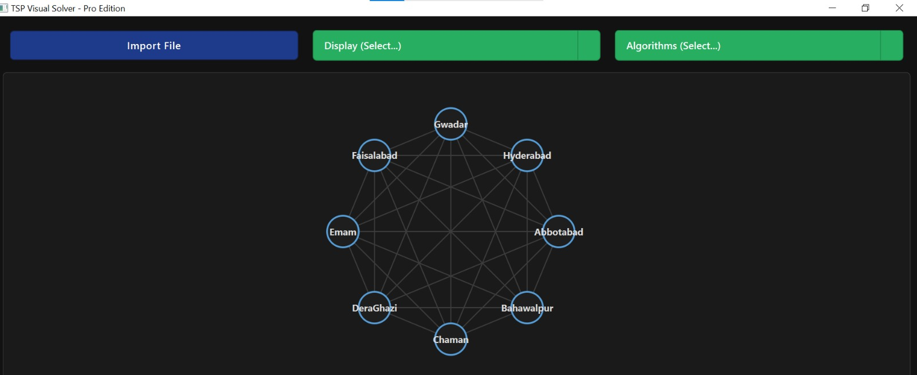
Brute Force Algorithm:
] 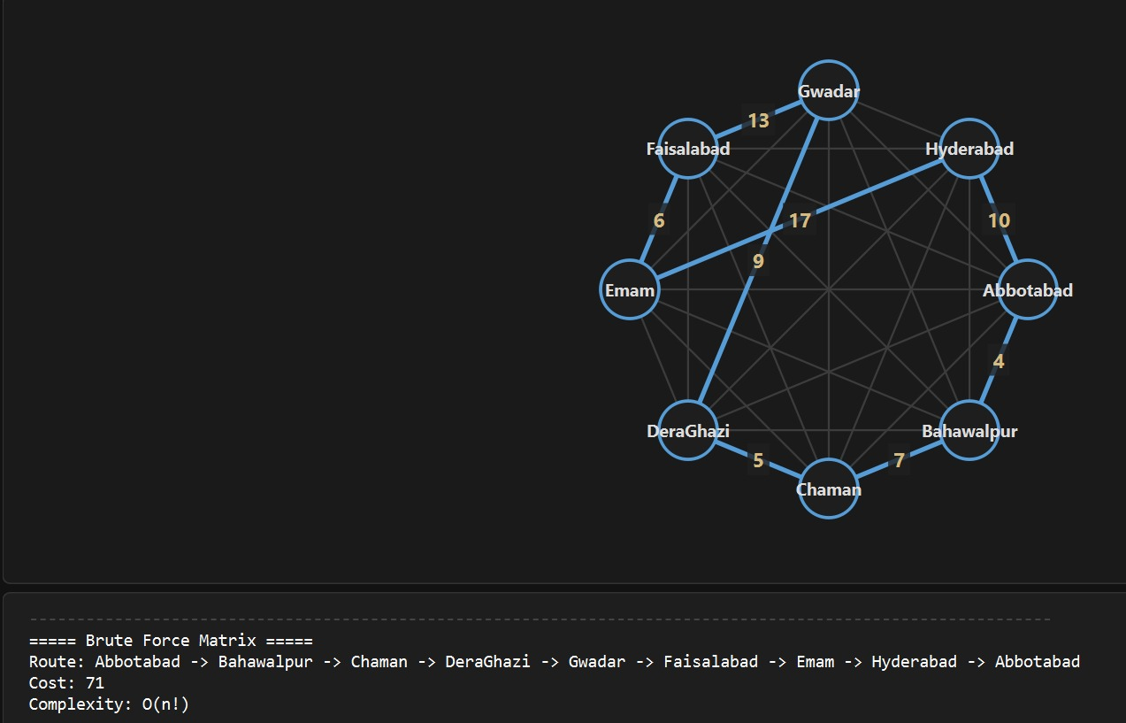
Greedy Algorithm:

Custom(Second shortest path) Algorithm:
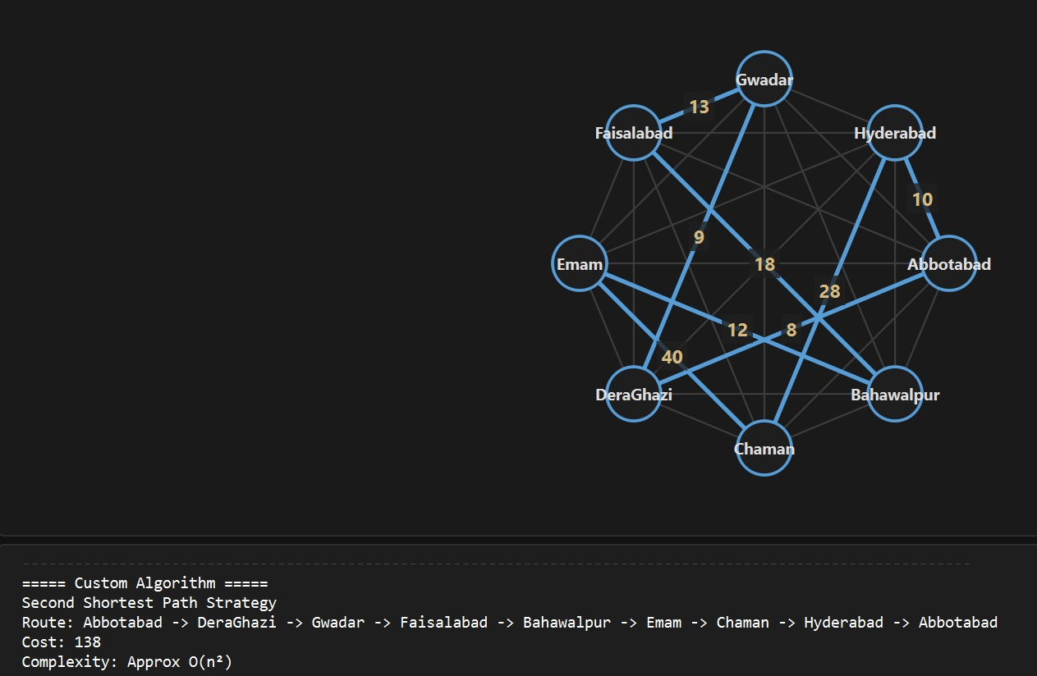

Performance Analysis:
The Travelling Salesman Problem was analyzed using Brute Force, Greedy, and Custom algorithms with static and dynamic graph representations. The Brute Force algorithm checked all possible routes and produced the optimal solution, but it required more execution time because of its high complexity O(n!).
The Greedy algorithm was much faster because it selected the nearest unvisited city instead of checking every route. However, it did not always guarantee the shortest possible path. The static adjacency matrix representation provided faster access, while the dynamic linked list representation used memory more efficiently.
The Custom algorithm used a Second Shortest Path Strategy, where an alternative path could be selected instead of the immediate shortest path. It performed faster than Brute Force and demonstrated a different heuristic approach for solving the problem. Overall, Brute Force was the most accurate, while Greedy and Custom algorithms were more efficient for larger graphs.

Comparison Table:
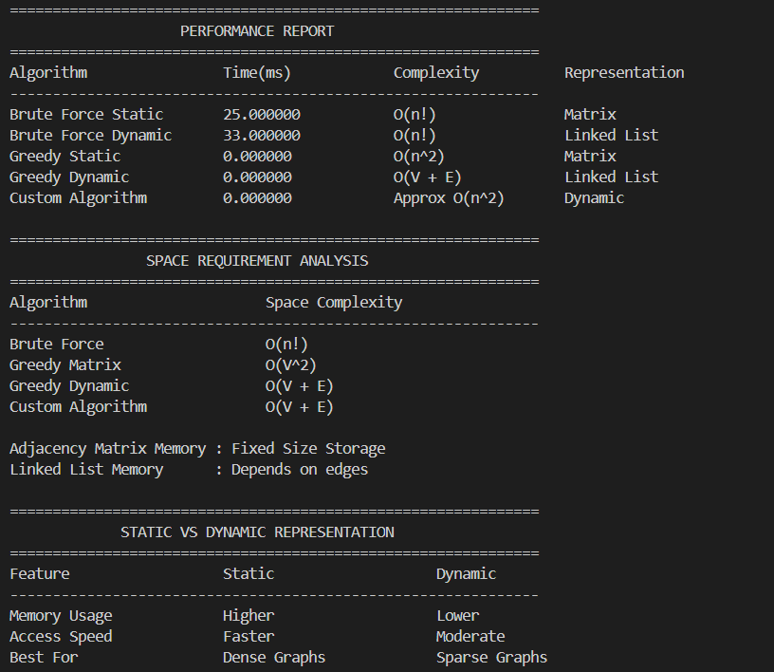

Task Division:
Abdul Moiz | Raja Arslan
1:Implemented console-based TSP system, graph representations, algorithms, performance analysis | 1: Developed Qt GUI visualization, integrated algorithms with interface
2:Report documentation. | 2: Report preparation

Conclusion:
This project successfully implemented the Travelling Salesman Problem using different algorithms and graph representations. Brute Force provided the most accurate route but required more execution time, while Greedy and Second Shortest Path Strategy algorithms produced faster results with lower complexity. The project also compared static and dynamic graph representations in terms of speed and memory usage. In addition, the Qt interface improved visualization and user interaction. Overall, the project helped in understanding graph algorithms, performance analysis, and practical applications of Data Structures and Algorithms.

Citation:
1: Data Structures and Algorithms course lecture slides and class material.
2: Qt Documentation Used for Qt GUI implementation and graph visualization.
3: OpenAI ChatGPT — Used for guidance, debugging assistance, explanation of concepts, and report writing support.
********************************************************************

